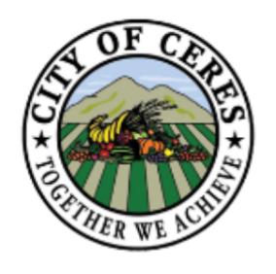
APPENDIX D
SMOKING POLICY
______________________________________________________________________________
SUBJECT
Smoking Policy – City Facilities

PURPOSE AND INTENT
Pursuant to Ordinance 6.03.030, establishes City of Ceres no smoking policy in facilities, vehicles, and buildings.

POLICY
- Smoking shall be prohibited in all enclosed facilities within all owned or leased city buildings and facilities. This includes common work areas, auditoriums, classrooms, conference and meeting rooms, private offices, elevators, hallways, cafeterias, employee lounges or eating areas, stairs, restrooms, vehicles, and all other enclosed facilities.

- Employees and volunteers with assigned vehicles, as well as employees and volunteers using City vehicles only occasionally, are prohibited from smoking in those vehicles.

- Smoking will be allowed only in outside areas.

“Smoking” according to ordinance means inhaling, exhaling, burning or carrying any lighted, heated or ignited cigar, cigarette, cigarillo, pipe, hookah, electronic smoking device or paraphernalia; or engaging in an act that generates smoke; or lighting or igniting a pipe, a hookah pipe, a cigar, or a cigarette of any king including, but not limited to, an electronic cigarette..

Violation of this policy may subject the violator to disciplinary action and possible action for an infraction under City Ordinance 6.03.130. Conviction of an infraction carries a fine of $100 for the first offense; $200 for the second (in the same year); and $500 for the third offense for each violation thereafter (in the same year).

