City of Ceres



Workplace Violence Prevention Policy

©(2024) Du-All Safety, LLC. All Rights Reserved. No part of this document may be reproduced by any means, electronic or mechanical, including photocopy, recording, or any information storage and retrieval system, without written permission first from Du-All Safety, LLC. This document is for the internal use of the City of Ceres only. Du-All and the City of Ceres are the only authorized entities allowed to alter or reproduce this document for internal use.

TABLE OF CONTENTS

Section PAGE
1.0 INTRODUCTION 5
2.0 SCOPE AND Application 5
3.0 Definitions 6
3.1 GENERAL 6
3.2 LABOR CODE SECTION 6401.9. (a) 6
3.3 SENATE BILL 553 7
4.0 Regulatory Requirements and References Summary 8
5.0 PROHIBITED CONDUCT 8
6.0 WARNING SIGNS 8
7.0 REPORTING INCIDENTS 9
8.0 RESPONSIBILITIES 9
8.1 CITY OF CERES 9
8.2 CITY MANAGER 10
8.3 HUMAN RESOURCES 10
8.4 MANAGERS & SUPERVISORS 10
8.5 EMPLOYEES 10
9.0 RECORD RETENTION 10
11.0 RESPONSE TO INCIDENTS OF WORKPLACE VIOLENCE/RELATED BEHAVIOR 11
11.1 ALL EMPLOYEES 11
11.2 MANAGERS & SUPERVISORS 12
11.3 REPORTS OF VIOLATIONS 12
11.4 RETALIATION 12
12.0 TRAINING 13

APPENDIX A- WORKPLACE VIOLENCE INCIDENT LOG
APPENDIX B- IDENTIFICATION OF RISKS
APPENDIX C- WORKPLACE VIOLENCE RISK ASSESSMENT
APPENDIX D – WORKPLACE VIOLENCE INCIDENT REPORT FORM
REVISION HISTORY LOG

Date | Name | Section | Description
May 2024 | Du-All Safety | All | New Policy

1.0 INTRODUCTION
Across the nation, incidents of workplace violence and threats of violence have significantly increased in recent years. Immediate victims as well as others are affected by incidents of workplace violence or threats of violence, including fellow employees, family members, and clients. The physical injuries, emotional distress, and potential loss of life resulting from incidents of workplace violence may have long-term effects. Incidents of violence or threats of violence may also have an impact on productivity and the effectiveness of the organization for an extensive period of time.
The City of Ceres recognizes the importance of providing a safe work environment. For this reason, this Workplace Violence Prevention Policy has been developed. The plan shall be in effect at all times and in all work areas and be specific to the hazards and corrective measures for each work area and operation.
This policy, which is in conformance with Cal/OSHA guidelines and Senate Bill 553, is intended to identify the following:
- Definitions
- What constitutes violence or threats of violence
- Conduct that is prohibited
- Warning signs of workplace violence
- The importance of reporting workplace violence
- An incident log process to track workplace violence incidents
- Department responsibilities
- Records and retention requirements
- Resources available in the event of a workplace violence crisis
- How to respond to incidents of workplace violence and/or related behaviors
- Training requirements to implement this policy

2.0 SCOPE AND Application
This program is applicable to all City employees as defined in Cal/OSHA regulations and Senate Bill 553. This plan has the objective of:
- Designating persons responsible for the plan.
- Effective procedures to obtain the active involvement of employees and authorized employee representatives in developing and implementing the plan.
- Methods the employer will use to coordinate the plan with employees and to ensure compliance by all employees.
- Effective procedures for the employer to accept and respond to reports of workplace violence, and to prohibit retaliation against an employee who makes such a report.
- Effective procedures to communicate with employees regarding workplace violence, including how to report a violent incident, threat or other workplace violence concern; effective means to alert employees to the presence of a workplace violence emergency; and how to obtain help from staff assigned to respond and/or law enforcement.
- Procedures to identify and evaluate workplace violence hazards, including scheduled periodic inspections, and to correct any identified hazards.
- Procedures for post-incident response and investigation.
- Procedures to review and revise the plan as needed, including with the active involvement of employees and authorized employee representatives.
- Initial training about the plan when first established and annual training.

3.0 Definitions

3.1 GENERAL
“Intimidation” means Inspiring fear in a person by a show of force or a promise of force.
“Physical Fighting” means the act of aggression or initial force in physically contending with another with the intent to overpower and/or to cause harm.
“Threat” means an expression of a direct (intent to take an action) or indirect (what could happen or that something could happen) intention to inflict pain, injury or punishment upon another person or property.
“Violence” means an aggressive acts or initiation of physical force exerted for the purpose of violating, damaging or abusing others.
“Weapons” means an instrument, article or substance, which in the possession of an employee or under the circumstances of which it is used or is threatened to be used, is readily able of causing physical injury or death.

3.2 LABOR CODE SECTION 6401.9. (a)
“Emergency” means unanticipated circumstances that can be life-threatening or pose a risk of significant injuries to employees or other persons.
“Engineering controls” mean an aspect of the built space or a device that removes a hazard from the workplace or creates a barrier between the worker and the hazard.
“Log” means the violent incident log required by this section.
“Plan” means the workplace violence prevention plan required by this section.
“Threat of violence” means any verbal or written statement, including, but not limited to, texts, electronic messages, social media messages, or other online posts, or any behavioral or physical conduct, that conveys an intent, or that is reasonably perceived to convey an intent, to cause physical harm or to place someone in fear of physical harm, and that serves no legitimate purpose.
(A) “Workplace violence” means any act of violence or threat of violence that occurs in a place of employment.
(B) Workplace violence includes, but is not limited to, the following:
(i) The threat or use of physical force against an employee that results in, or has a high likelihood of resulting in, injury, psychological trauma, or stress, regardless of whether the employee sustains an injury.
(ii) An incident involving the threat or use of a firearm or other dangerous weapon, including the use of common objects as weapons, regardless of whether the employee sustains an injury.
(iii) The following four workplace violence types:
(I) “Type 1 violence” means workplace violence committed by a person who has no legitimate business at the worksite and includes violent acts by anyone who enters the workplace or approaches workers with the intent to commit a crime.
(II) “Type 2 violence” means workplace violence directed at employees by customers, clients, patients, students, inmates, or visitors.
(III) “Type 3 violence” means workplace violence against an employee by a present or former employee, supervisor, or manager.
(IV) “Type 4 violence” means workplace violence committed in the workplace by a person who does not work there but has or is known to have had a personal relationship with an employee.

3.3 SENATE BILL 553
“Course of conduct” means a pattern of conduct composed of a series of acts over a period of time, however short, evidencing a continuity of purpose, including following or stalking an employee to or from the place of work; entering the workplace; following an employee during hours of employment; making telephone calls to an employee; or sending correspondence to an employee by any means, including, but not limited to, the use of the public or private mails, interoffice mail, facsimile, or computer email.
“Credible threat of violence” means knowing and willful statement or course of conduct that would place a reasonable person in fear for their safety, or the safety of their immediate family, and that serves no legitimate purpose.
“Employer” and “Employee” means persons defined in Section 350 of the Labor Code. “Employer” also includes a federal agency, the state, a state agency, a city, county, or district, and a private, public, or quasi-public corporation, or any public agency thereof or therein. “Employee” also includes the members of boards of directors of private, public, and quasi-public corporations and elected and appointed public officers. For purposes of this section only, “Employee” also includes a volunteer or independent contractor who performs services for the employer at the employer’s worksite.
“Harassment” means knowing, and willful course of conduct directed at a specific person that seriously alarms, annoys, or harasses the person, and that serves no legitimate purpose. The course of conduct must be that which would cause a reasonable person to suffer substantial emotional distress, and must actually cause substantial emotional distress.
“Petitioner” means the employer that petitions under subdivision (a) for a temporary restraining order and order after hearing.
“Respondent” means the person against whom the temporary restraining order and order after hearing are sought and, if the petition is granted, the restrained person.
“Temporary restraining order” and “order after hearing” means orders that include any of the following restraining orders, whether issued ex parte or after notice and hearing:
An order enjoining a party from harassing, intimidating, molesting, attacking, striking, stalking, threatening, sexually assaulting, battering, abusing, telephoning, including, but not limited to, making annoying telephone calls as described in Section 653m of the Penal Code, destroying personal property, contacting, either directly or indirectly, by mail or otherwise, or coming within a specified distance of, or disturbing the peace of, the employee.
An order enjoining a party from specified behavior that the court determines is necessary to effectuate orders described in subparagraph (A).
“Unlawful violence” means any assault or battery or stalking as prohibited in Section 646.9 of the Penal Code but shall not include lawful acts of self-defense or defense of others.

4.0 Regulatory Requirements and References Summary
- Title 8 of the California Code of Regulations (T8CCR) section 3203 requires every employer to develop and implement an effective IIPP. An effective IIPP improves the safety and health in your workplace and reduces costs by good management and employee involvement.
- California SB 553, which takes effect July 1, 2024, creates the first general industry workplace violence prevention safety requirements in the United States.
- Covered employers must develop and create a workplace violence prevention plan as part of their Injury and Illness Prevention Plans that meets the requirements of the new Labor Code Section 6401.9 and Section 527.8 Code of Civil Procedure by the law’s July 1, 2024, effective date.

5.0 PROHIBITED CONDUCT
Conduct, which is prohibited includes, but is not limited to violence, direct or indirect threats of violence, intimidation, bullying, physical fighting, or unauthorized use or possession of weapons.

6.0 WARNING SIGNS
Prohibited conduct encompasses a range of behaviors, including but not limited to acts of violence, direct or indirect threats of violence, intimidation, physical altercations, and the unauthorized use or possession of weapons.
The most evident sign of potential violence is a threat, encompassing direct threats, veiled threats, and threats contingent upon other actions. For example, an employee receives repeated phone calls of a volatile nature should be reported.
Additional signs or behaviors that may be indicative of potential threats include an individual who:
- Displays unusual argumentativeness
- Demonstrates a lack of cooperation with others
- Frequently attributes problems to others
- Shows noticeable changes in work patterns, such as tardiness or absenteeism
- Displays extreme or unusual behavior
- Appears frequently depressed
- Engages in alcohol or drug abuse
- Has a history of violence
- Exhibits a preoccupation with weapons and their potential for harm to oneself or others
It's important to note that a potentially violent individual may not necessarily display all the listed signs. Caution should be exercised to avoid overreacting; for instance, being argumentative does not automatically imply a propensity for violence.

7.0 REPORTING INCIDENTS
Employees play a vital role in reducing the likelihood of such incidents by promptly addressing angry outbursts and reporting any instances of violence or threats of violence in adherence to the provisions outlined in this Workplace Violence Prevention Policy.
It is imperative that any episode involving violence or the potential for violence be reported. To ensure this, the City mandates that employees report such incidents by adhering to the following guidelines:
- Any employee on City property or on City business who witnesses or becomes aware of an individual (e.g., employee, visitor, contractor, vendor, etc.) engaging in, attempting, or committing a prohibited behavior or act of violence should immediately inform their immediate supervisor and or manager. If necessary, the employee may seek emergency assistance by dialing 911.
- Any employee who observes or becomes aware of any unauthorized possession, use, transfer, or sale of a weapon on City property or while employees are on City business should promptly report this to their immediate supervisor and or manager.
- An Incident Report Form is established to document the specific incidents, HR will take the lead with the supervisor to complete the Incident Report Form to capture the relevant facts.
- An incident log process is established to track workplace violence incidents, and the log must be accessible for inspection. HR will develop the Log which has personal information deleted since it is a public record.
The City is committed to making every reasonable effort to uphold the confidentiality of individuals reporting incidents of Workplace Violence.

8.0 RESPONSIBILITIES

8.1 CITY OF CERES
The City shall be responsible for the following:
- Informing all staff members about the Workplace Violence Prevention Policy.
- Distributing a copy of the policy to each employee.
- Assessing the hazards of workplace violence for City work areas and tasks and documenting this assessment as Appendix C. Workplace Violence Risk Assessment.
- Ensuring the attendance of all employees for training sessions on Workplace Violence Prevention.
- Identifying who will serve as primary contacts for responding to incidents involving workplace violence or prohibited behaviors.
- Ensuring that all employees comprehend their duty and obligation to treat any prohibited conduct or incidents of workplace violence seriously, advising them to seek assistance at the earliest signs of concern.

8.2 CITY HR DIRECTOR
The City HR Director shall be responsible for the implementation of this policy. The responsibility includes :
- Distribution of this policy to members of the city workforce.
- Ensuring appropriate investigation and follow‐up of reported incidents of workplace violence
- Ensuring that human resources staff, city managers and supervisors, and city employees are aware of their responsibilities under this policy through internal communications and training.

8.3 HUMAN RESOURCES DEPARTMENT
- Facilitate appropriate responses to reported incidents of workplace violence.
- With the assistance of supervisors assess the potential problem of workplace violence and recommend policy, training issues, or security procedures that should be implemented to maintain a safe working environment. (Reference Appendix B- Identification of Risks & Appendix C- Workplace Violence Risk Assessment).
- The HR Department will work with the City Finance Department to ensure contractors for the City have appropriate and effective Workplace Violence Prevention Policies in place.
- Utilize prevention, intervention, and interviewing techniques in responding to workplace violence.
- Develop workplace violence prevention tools (such as pamphlets, guidelines, and handbooks) to assist in recognizing and preventing workplace violence.
- Arrange regularly scheduled workplace violence prevention training sessions for employees.
- With the responsible supervisor, complete a Workplace Violence Incident Report Form (Appendix D) for each workplace violence incident.
- Maintain workplace violence incident logs for a minimum of 5 years.

8.4 MANAGERS & SUPERVISORS
- With the assistance of human resources, perform a risk evaluation of the workplace to determine the presence of factors or situations that might place employees at risk of workplace violence; a risk evaluation must be completed on an annual basis. (Reference Appendix B- Identification of Risks & Appendix C- Workplace Violence Risk Assessment).
- Assess the readiness for dealing with workplace violence.
- With HR, complete the Workplace Violence Incident Report Form (Appendix D), for each workplace violence incident.
- Evaluate incidents to prevent future occurrences.
- Assure employees attend regularly scheduled workplace violence prevention training.

8.5 EMPLOYEES
- Employees contribute to the preservation of a secure and safe workplace by adhering to the Workplace Violence Prevention Policy and the specific workplace violence prevention response plan implemented by their department.
- Report any workplace violence incident.
- Attending initial training and annual training.

9.0 RECORD RETENTION
- Records of workplace violence hazard identification, evaluation, and correction shall be created and maintained for a minimum of five years.
- Training records will be maintained for a minimum of one year.
- The Workplace Violence Incident Report Forms and the Workplace Violence Incident Logs shall be maintained for a minimum of five years.
- Records of workplace violence incident investigations shall be maintained for a minimum of five years. These records shall not contain “medical information,” as defined in subdivision (j) of Section 56.05 of the Civil Code.
- All records required by this subdivision shall be made available to the division of Labor upon request for examination and copying.
- All records required by paragraphs (1) to (3), inclusive, shall be made available to employees and their representatives, upon request and without cost, for examination and copying within 15 calendar days of a request.
The records will be retained by the Human Resources Department.

11.0 RESPONSE TO INCIDENTS OF WORKPLACE VIOLENCE/RELATED BEHAVIOR

11.1 ALL EMPLOYEES
It's essential for employees to be proactive in their approach to workplace violence prevention by staying informed, reporting concerns promptly, and cooperating with organizational measures to maintain a safe work environment. In a workplace violence situation, employees typically have several responsibilities to help ensure their safety and the safety of others. This response may include:
- Attending workplace violence prevention training sessions provided by the organization. Understand the signs of potential violence and learn appropriate responses.
- Employees should be familiar with and adhere to workplace violence prevention policies and procedures established by the organization.
- Stay alert to your surroundings and be aware of any signs or behaviors that may indicate potential violence as outlined in section 6.0 above.
- Report any incidents or threats of violence immediately to supervisors, managers, or designated personnel. Follow the established reporting procedures outlined in the workplace violence prevention policy.
IMMEDIATE THREAT
- Employees should avoid confronting potentially violent individuals whenever possible. Focus on personal safety and use escape routes if available.
- In the event of an immediate threat, employees should know how to access emergency resources, including calling 911 or using any emergency response systems in place.
- If law enforcement or security personnel are involved, cooperate fully with their instructions. Provide information and details about the incident as accurately as possible.
- If necessary, seek shelter or a safe location within the workplace. Follow any established lockdown or evacuation procedures.
- If trained and it is safe to do so, provide first aid to injured individuals while waiting for professional medical assistance.
- If reporting an incident, be aware of and comply with the confidentiality measures outlined in the workplace violence prevention policy. Understand the importance of maintaining confidentiality in certain situations. (Reference Section 11.3 Reports of Violations)
- Offer support to colleagues who may be victims of workplace violence or who have witnessed incidents. Encourage them to report incidents and seek assistance.

11.2 MANAGERS & SUPERVISORS
Each supervisor, including department heads, executive officers, administrators, or those with supervisory responsibilities, is accountable for implementing this policy within their jurisdiction. Supervisors must immediately contact the City Police Department in cases of imminent or actual violence involving weapons or potential physical injuries. They are also required to inform their immediate supervisor and Human Resources about any complaints, acts, or threats under this policy, even if resolved. Failure by a supervisor to investigate and take appropriate action may result in administrative measures, including possible discipline.

11.3 REPORTS OF VIOLATIONS
Individuals witnessing or experiencing imminent danger, personal injury, or violence involving weapons or actual violence should immediately dial 911.
Upon receiving a written report of a policy violation, the Supervisor shall conduct a preliminary inquiry using the Workplace Violence Incident Report form as a guide. The inquiry shall see to determine:
- Immediate threats of violence, if identified, will prompt notification to local police and emergency medical personnel, following the outlined procedures below.
- Serious misconduct or criminal behavior by an employee, if discovered, will lead to an investigation involving the Supervisor/Manager and law enforcement if necessary.
- There is no immediate threat of violence and no serious misconduct or criminal behavior by an employee will result in the Supervisor/Manager termination of the investigation.
Employees breaching this policy may face disciplinary action, including dismissal, criminal prosecution, and/or civil prosecution as deemed appropriate.

11.4 RETALIATION
Retaliation against an employee who makes a good-faith report of violence or other disruptive behavior is strictly prohibited and will be met with appropriate corrective or disciplinary measures. An employee making a false report in bad faith is also subject to disciplinary action.

12.0 TRAINING
The City shall provide effective training to employees and the training material will be appropriate in content and vocabulary to the educational level, literacy, and language of employees shall be used.
The City shall provide employees with initial training when the plan is first established, and annually thereafter, on all of the following:
- The plan, how to obtain a copy of the plan at no cost, and how to participate in development and implementation of the plan.
- The definitions and requirements of this section.
- How to report workplace violence incidents or concerns to management or law enforcement without fear of reprisal.
- Workplace violence hazards specific to the employees’ jobs, the corrective measures the employer has implemented, how to seek assistance to prevent or respond to violence, and strategies to avoid physical harm.
- The violent incident log as required and how to obtain copies of the records.
- An opportunity for interactive questions and answers with a person knowledgeable about the plan.
Additional training shall be provided when a new or previously unrecognized workplace violence hazard has been identified and when changes are made to the plan. The additional training may be limited to addressing the new workplace violence hazard or changes to the plan.
Training records shall be created and maintained for a minimum of one year and include training dates, contents or a summary of the training sessions, names and qualifications of persons conducting the training, and names and job titles of all persons attending the training sessions.

APPENDIX A
WORKPLACE VIOLENCE INCIDENT LOG
This log is to be completed for each reported incident of workplace violence. The employer shall omit any element of personal identifying information sufficient to allow identification of any person involved in a violent incident.
Date and Time of Incident:
________________ _________________
[MM/DD/YYYY] [HH:MM AM/PM]
Location of Incident:
[Provide a detailed location, including specific address or area]

Workplace Violence Type(s):
[ ] Type 1: No legitimate business at the worksite
[ ] Type 2: Violence directed at employees by customers, clients, etc.
[ ] Type 3: Violence against an employee by a present or former employee, supervisor, or manager
[ ] Type 4: Violence committed by a person not working at the site but has/had a personal relationship with an employee
Detailed Description of Incident:
[Provide a thorough and accurate description of the incident, including relevant details.]

Classification of Perpetrator:

[ ] Client or Customer
[ ] Family or Friend of a Client or Customer
[ ] Stranger with Criminal Intent
[ ] Coworker
[ ] Supervisor or Manager
[ ] Partner or Spouse
[ ] Parent or Relative
[ ] Other (Specify): ___________

Classification of Circumstances at the Time of Incident:

[ ] Completing usual job duties
[ ] Working in poorly lit areas
[ ] Rushed
[ ] Working during low staffing levels
[ ] Isolated or alone
[ ] Unable to get help or assistance
[ ] Working in a community setting
[ ] Working in an unfamiliar or new location
[ ] Other (Specify): ___________

Classification of Incident Location:
[ ] In the workplace
[ ] Parking lot or other area outside the workplace
[ ] Other area (Specify): ___________

Type of Incident:

[ ] Physical attack without a weapon, including, but not limited to, biting, choking, grabbing, hair pulling, kicking, punching, slapping, pushing, pulling, scratching, or spitting.
(Specify): ___________
[ ] Attack with a weapon or object, including, but not limited to, a firearm, knife, or other object. (Specify): ___________
[ ] Threat of physical force or threat of the use of a weapon or other object (Specify): __________
[ ] Sexual assault or threat, including, but not limited to, rape, attempted rape, physical display, or unwanted verbal or physical sexual contact.
[ ] Animal attack
[ ] Other (Specify): _________

Consequences of the Incident:
(i) Security or law enforcement contacted. [ ] Yes [ ] No
(ii) Their response: _________________________________________________
(iii) Actions taken to protect employees from a continuing threat or other hazards identified as a result of the incident: _________________________________________________
Information about the Person Completing the Log:
Name: _________________________ Job Title:___________________
Date Completed:__________

APPENDIX B
IDENTIFICATION OF RISKS
The City has recognized the following potential risks:
- Irate residents who may become upset over a decision or action of an employee, Board, or other decision-maker.
- Individuals who are or appear to be under the influence of alcohol or drugs.
- Individuals becoming angry at an athletic or recreation event.
- Individuals seeking to steal money or other property.
- Violence or threats directed at employees for personal reasons by their family members, partners, or other individuals.
- Individuals become angry with employees after an accident.
- Intimidating or attempting to coerce an employee to engage in wrongful acts that would affect the business interests.
- Harassing surveillance, also known as "stalking," involves the willful, malicious, and repeated following of another person, making a credible threat with the intent to place the other person in reasonable fear of their safety.
- Making suggestions or intimidating that an act to injure persons or property is "appropriate," irrespective of the location where such suggestion or intimidation occurs.
- Unauthorized possession or inappropriate use of firearms, weapons, or any other dangerous devices on company property.
- Intimidating, belligerent, harassing, bullying, or engaging in other inappropriate and aggressive behavior.
- Numerous conflicts with supervisors and other employees.
- Drug/alcohol abuse.
- Extreme changes in an individual's behavior.
Employment situations/factors including:
- Working in a public setting.
- Working late at night or early morning hours.
- Exchanging money with the public.
- Working alone or in small numbers.
- Working in a setting with uncontrolled access to the workplace.
- Working in a setting where previous security problems have occurred.
- Having a mobile workplace assignment.
- Working with a population that might expose one to potentially violent people.
- Having duties that include the delivery of passengers, goods, or services.
Employee issues:
- Negative performance review.
- Unwelcome change in role due to performance or reorganization.
- Criticism of performance.
- Increased workload or pressure.

APPENDIX C
WORKPLACE VIOLENCE RISK ASSESSMENT
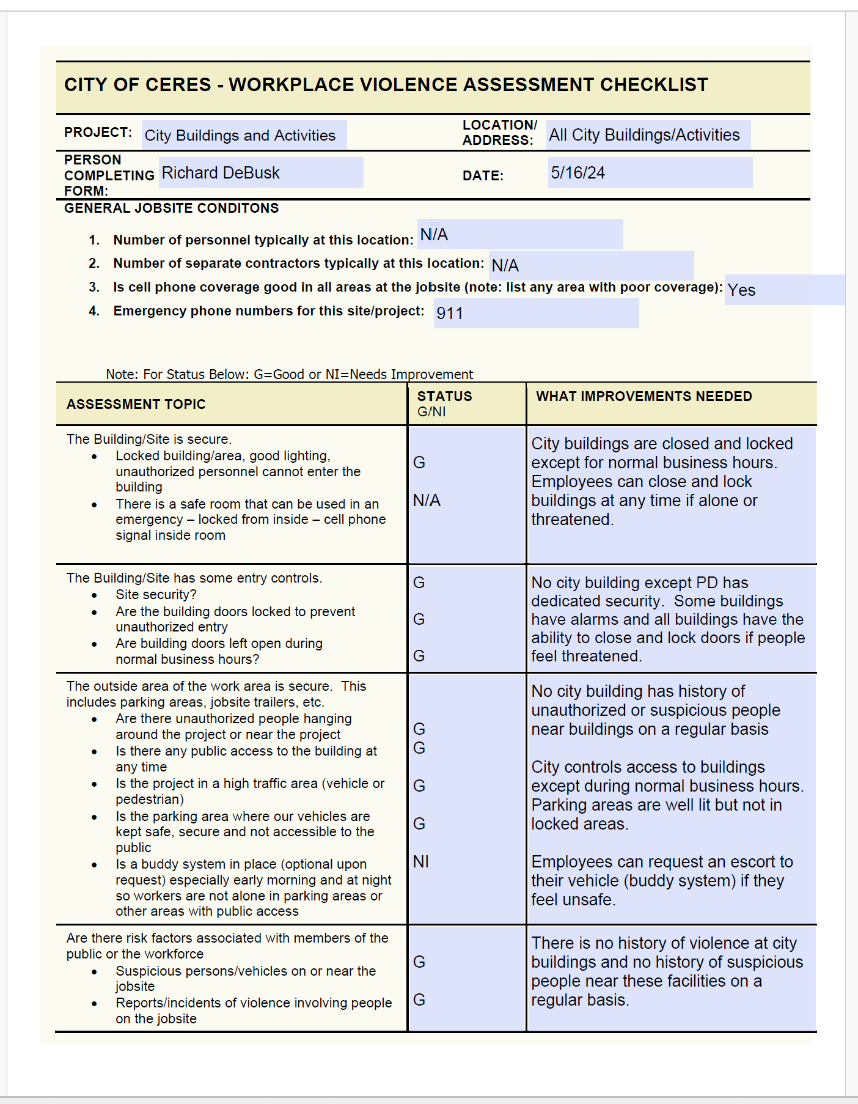
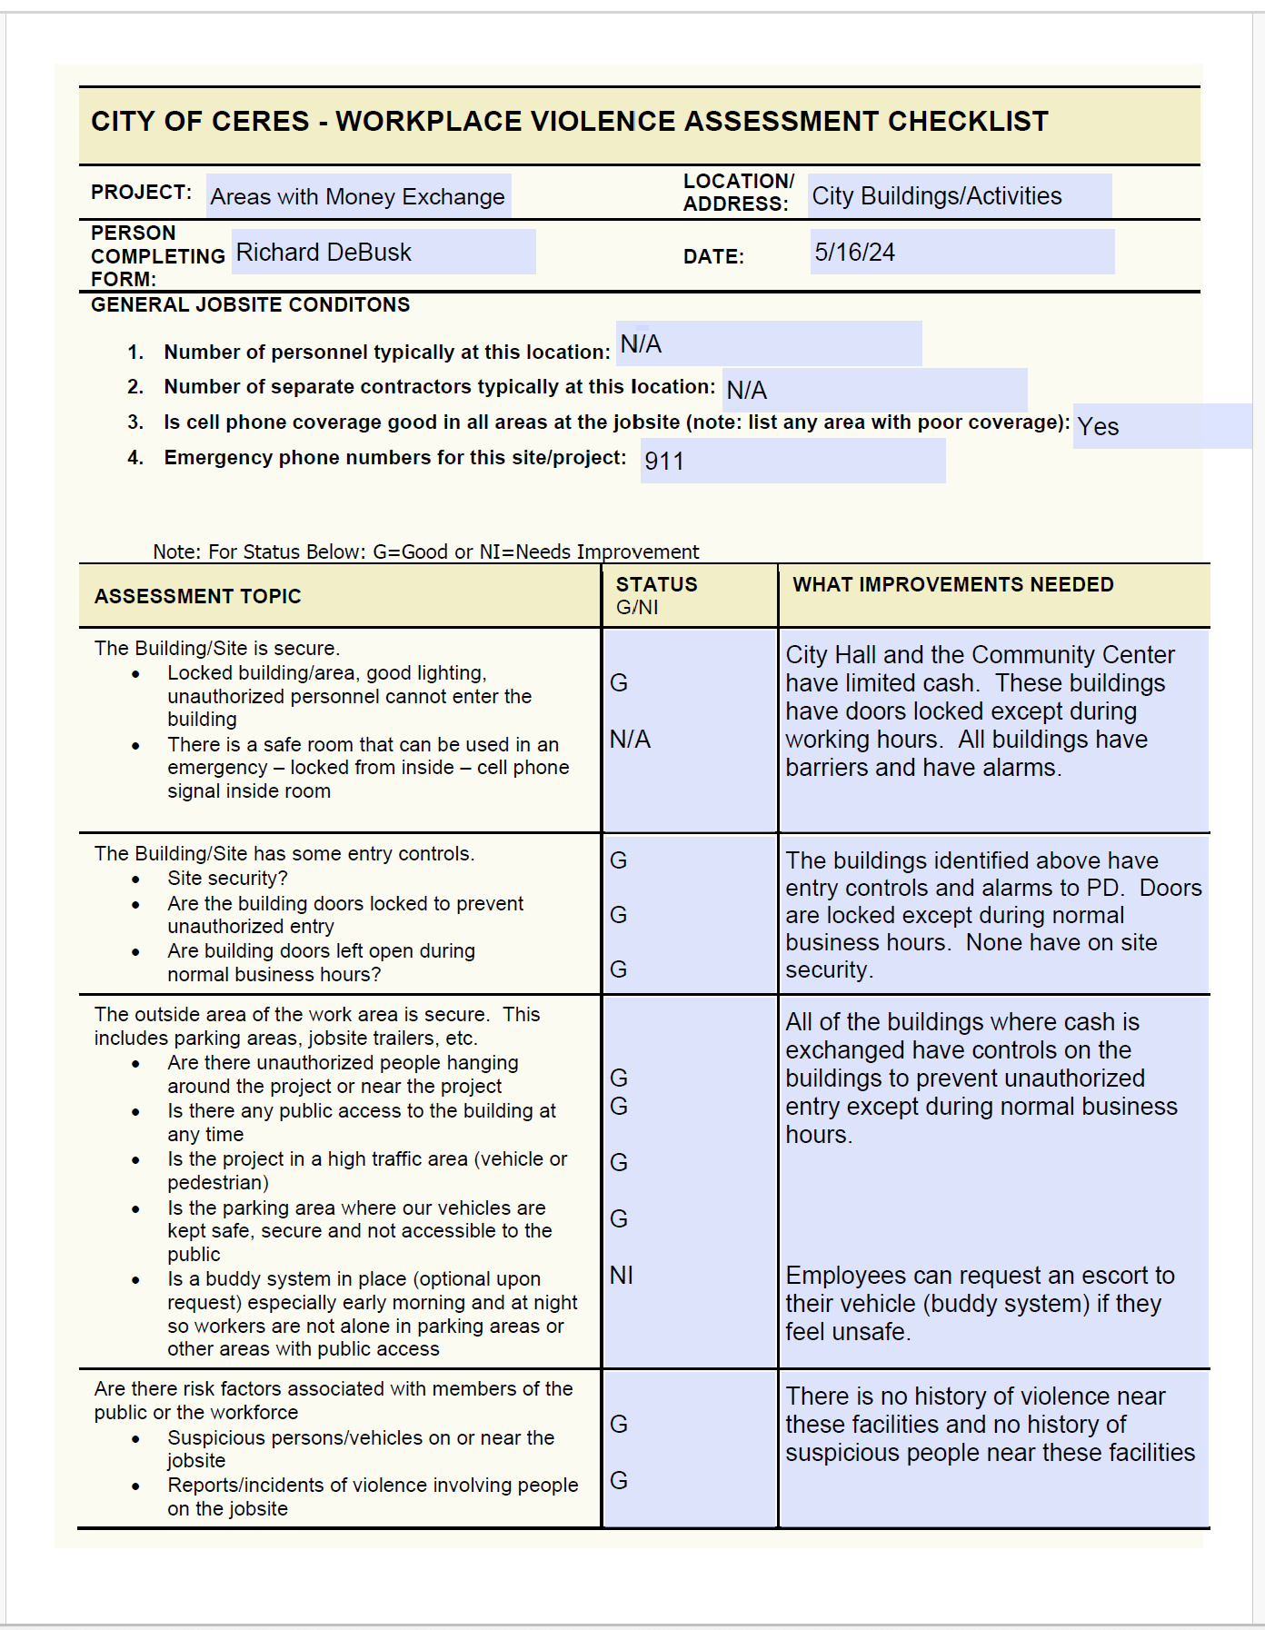

Appendix D
Workplace Violence Incident Report form
1. Status of Person Reporting:  Employee Visitor  City Contractor  Other ____________________ | 2. Date of incident (mm/dd/yyyy): |  |  | 3. Time of incident:  AM PM
4. Name of Person Reporting: (Last, First, MI) |  |  | 5. Phone #: |  |  | 6. Alternate #:
7. City Workplace Address |  |  | 8. Email:
9. Address or location of incident: (be specific about the building, inside or outside of building, etc.)

10. Nature of the incident (note: check box and describe incident below) Threat Assault Other (explain below)

- Were there injuries: Yes No If yes, Describe below the injury and any first aid or medical treatment received.

12. Witnesses name, and contact information:

Management Assessment (Items 13 and 14 below to be completed by Human Resources)
- Incident Assessment:

14. Corrective Action

15. Signature of Person Completing Report: |  | 16. Human Resources Representative: |  |  | 17. Date Submitted:
This form is for reporting Workplace Violence incidents

